**Module 7 – Critical Thinking**

Dominic A. Suarez

Colorado State University Global

CSC 500-1: Principles of Programming

Dr. Lori Farr

April 7, 2024

**Module 7 Critical Thinking**

Write a program that creates a dictionary containing course numbers and the room numbers of the rooms where the courses meet. The dictionary should have the following key-value pairs:

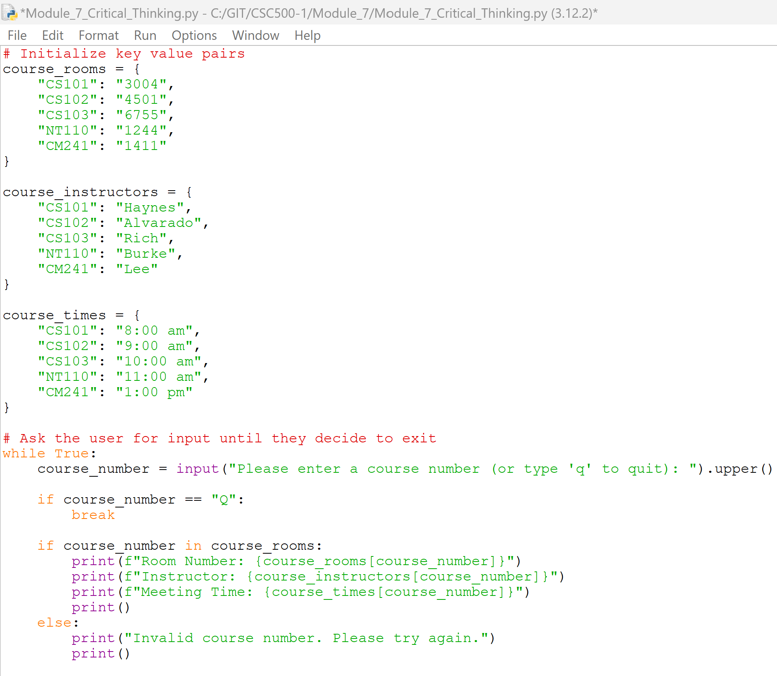

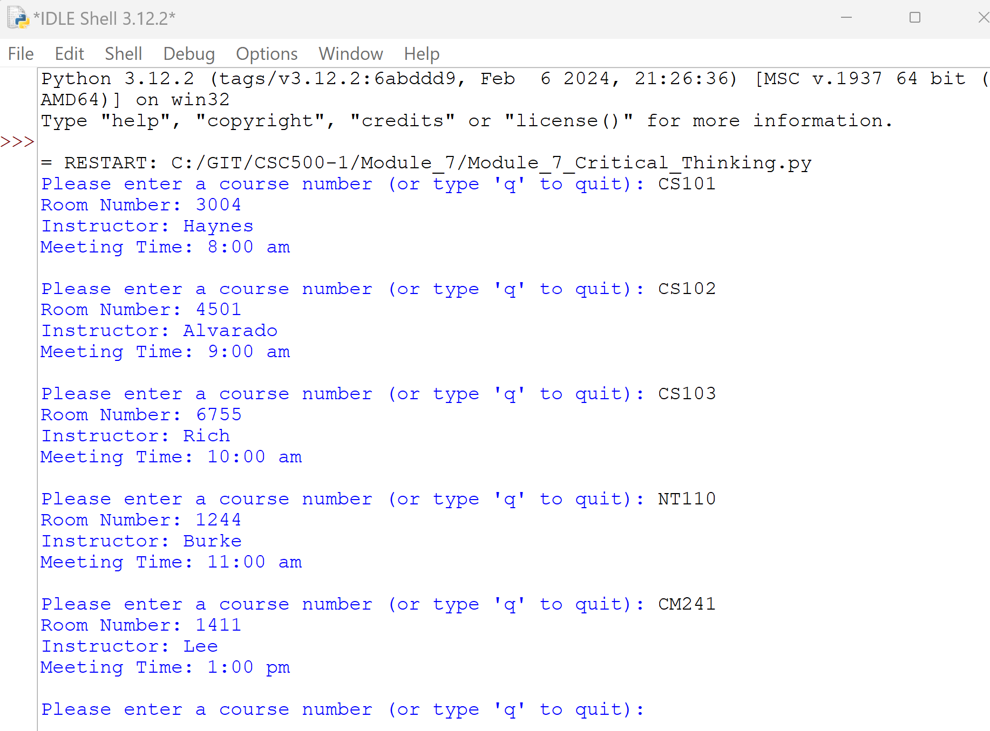

*Git repository is found at*

*https://github.com/dominic-suarez/CSC500-1*